**World Quant University**

**Professor: Tiberiu Stoica**

**Machine Learning**

Nikolas Lippmann Pareschi - [nikolaslippmann@gmail.com](mailto:nikolaslippmann@gmail.com)

**Unit 1 Project**

For this project I used MariaDB. Please install Maria DB from:

<https://mariadb.com>

I followed the tutorial in this site, which explains a lot about Mariadb and even how to download and populate the database with the data:

<https://reasonabledeviations.science/2018/02/01/>

When you download and install Mariadb you will set a password. This will be use in the python connection. I used password as password.

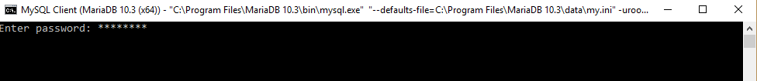

Then run prompt to start the database using the password previously defined in the installation.

After that we need to create the database:



After that make sure to be in the right database:



Now we proceed creating the table exchange:

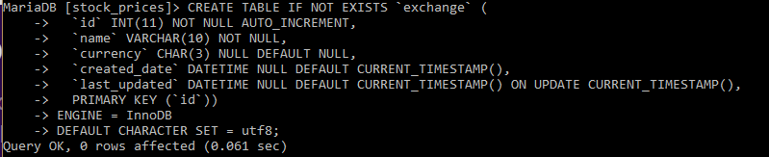

Afterwards we proceed creating the table security :

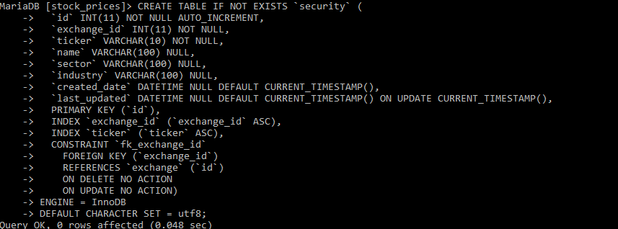

Now table data_vendor:

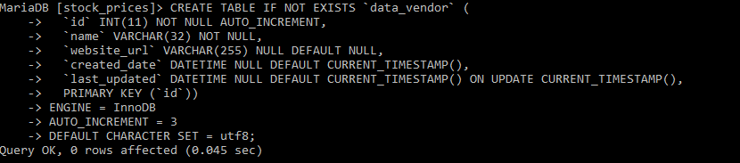

And finally the table daily_prices:

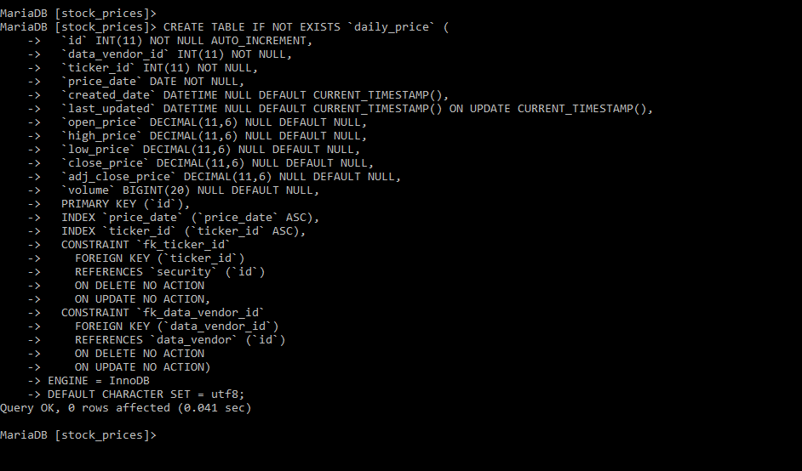

We then proceed to connecting to the database through python and populating it. We need also to use a list of stocks to download then afterwards from yahoo. We get the list from:

https://www.nasdaq.com/screening/companies-by-industry.aspx?exchange=NYSE

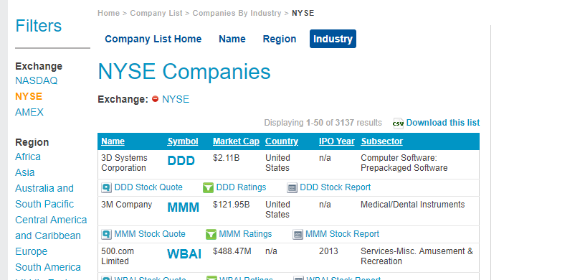

The we start our python program:

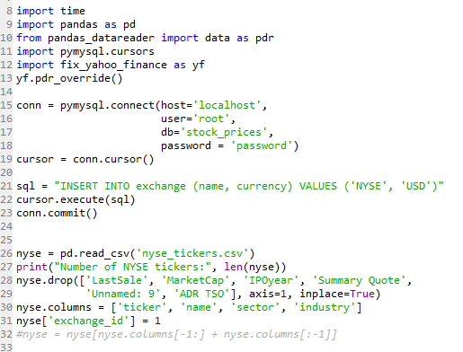

Remember that you must save the CSV file in your working directory.

Afterwards we proceed to downloading the price data:

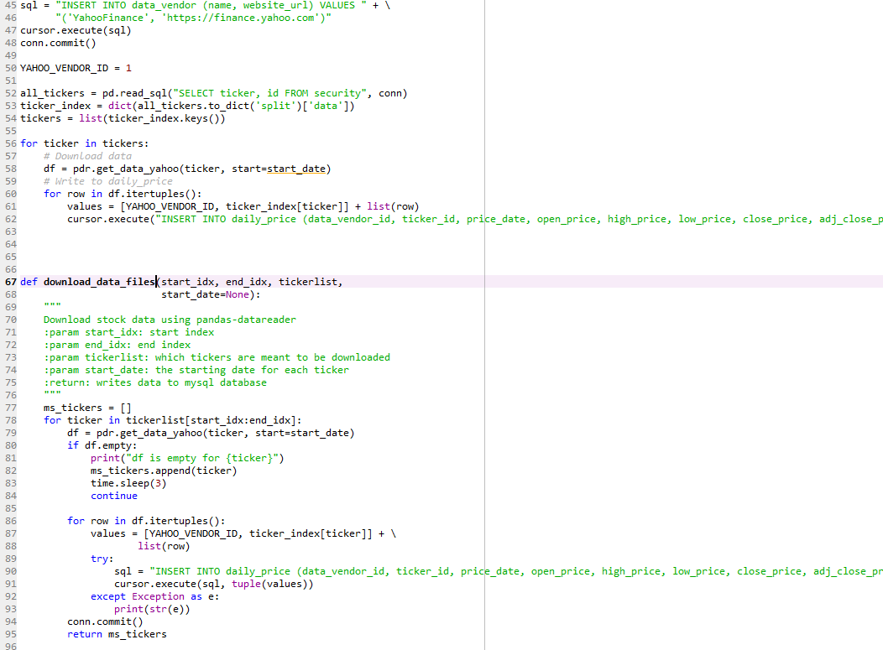

Unfortunately, I was not able to download the price data. But the database was successfully created and I made the objective of making a successful query:



